To complete this lesson, follow the learning steps.
Learning Roadmap
Learning Steps |  |  | Description | Link | Learning Objectives
1 |  | Learning Objectives
2 |  |  |  | Click Here
3 |  |  |  | Click Here
4 |  |  |  | Click Here
5 |  |  |  | Click Here
6 | 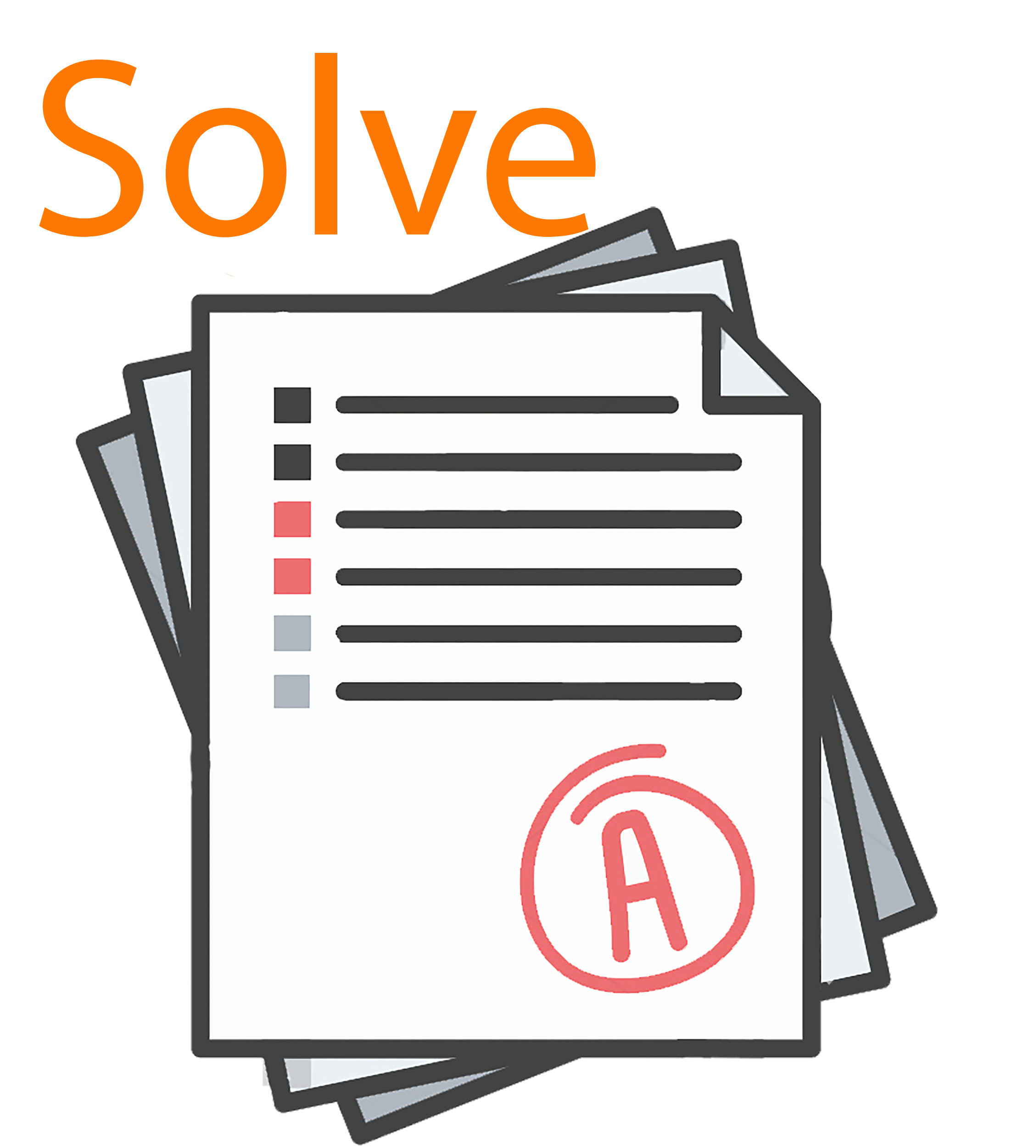 |  |  | Click Here
7
8
9

